PortSwigger Web Security Academy — Proof of Concept

GraphQL API Lab 2

Accidental exposure of private GraphQL fields
Category | GraphQL API
Lab | Lab 2
Completed By | Security Researcher
Platform | PortSwigger Web Security Academy

Lab Objective
Exploit accidentally exposed private user credentials in GraphQL query responses.

Step-by-Step Exploitation
- Open Burp Suite and configure browser proxy.
- Navigate to the lab URL and identify the vulnerable functionality.
- Intercept the relevant HTTP request in Burp Proxy.
- Send the request to Burp Repeater for analysis.
- Craft and inject the appropriate payload into the vulnerable parameter.
- Forward the modified request and observe the response.
- Verify the exploit was successful as shown in the screenshots below.

Screenshots & Evidence
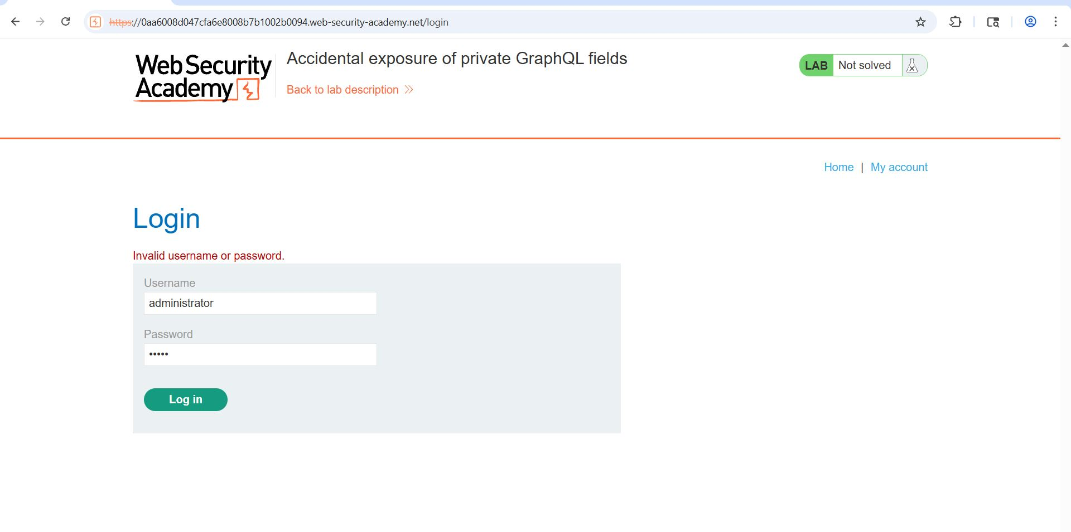
Figure 1: 1 Try Login Admin
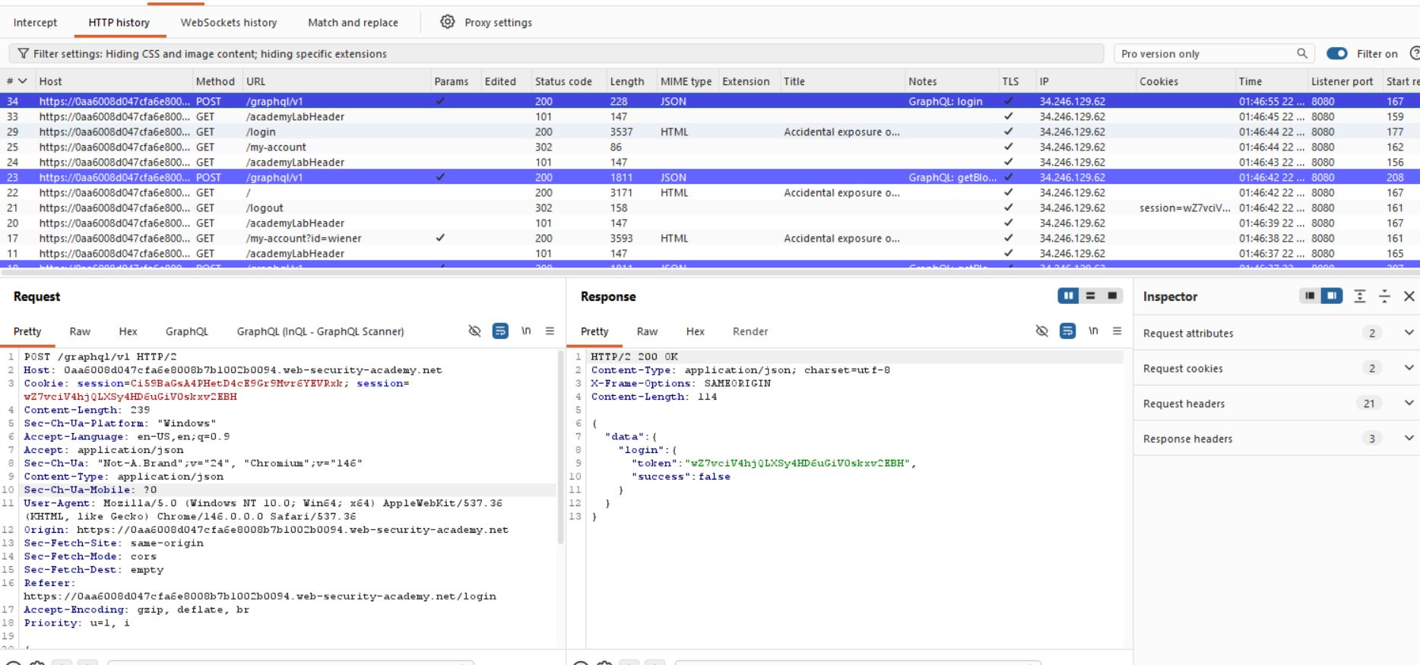
Figure 2: 2 Find Request Login GraphQL V1
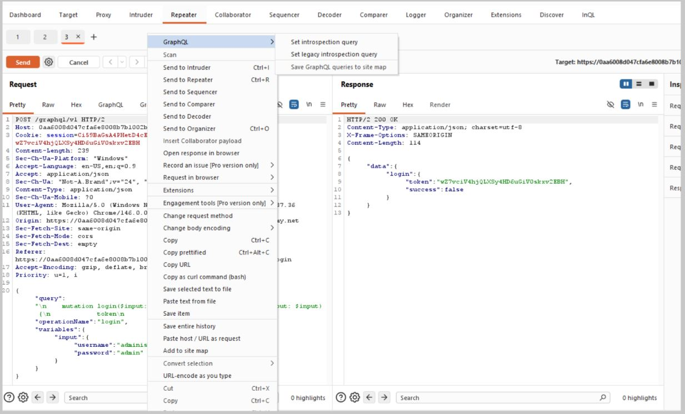
Figure 3: 3, Send To Intro Query
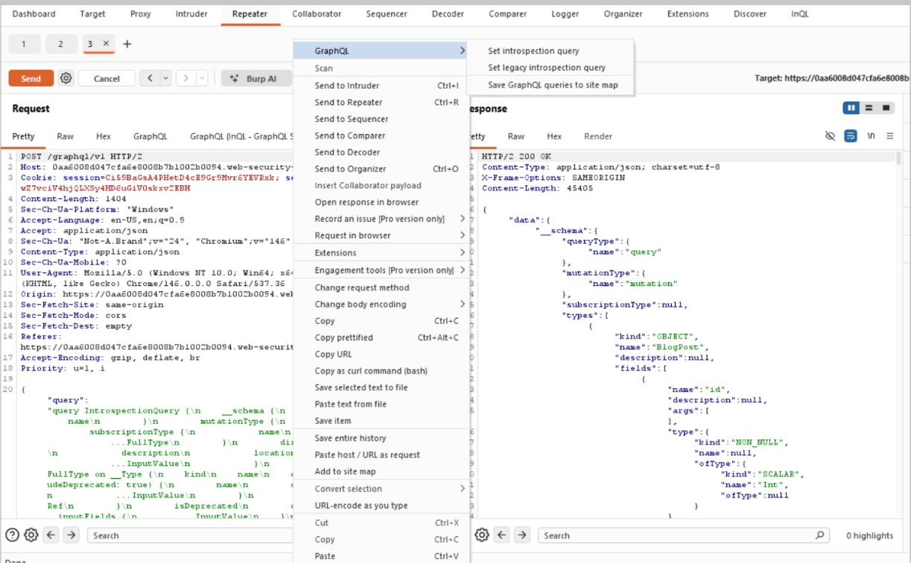
Figure 4: 4 Send To The QL Sitemap
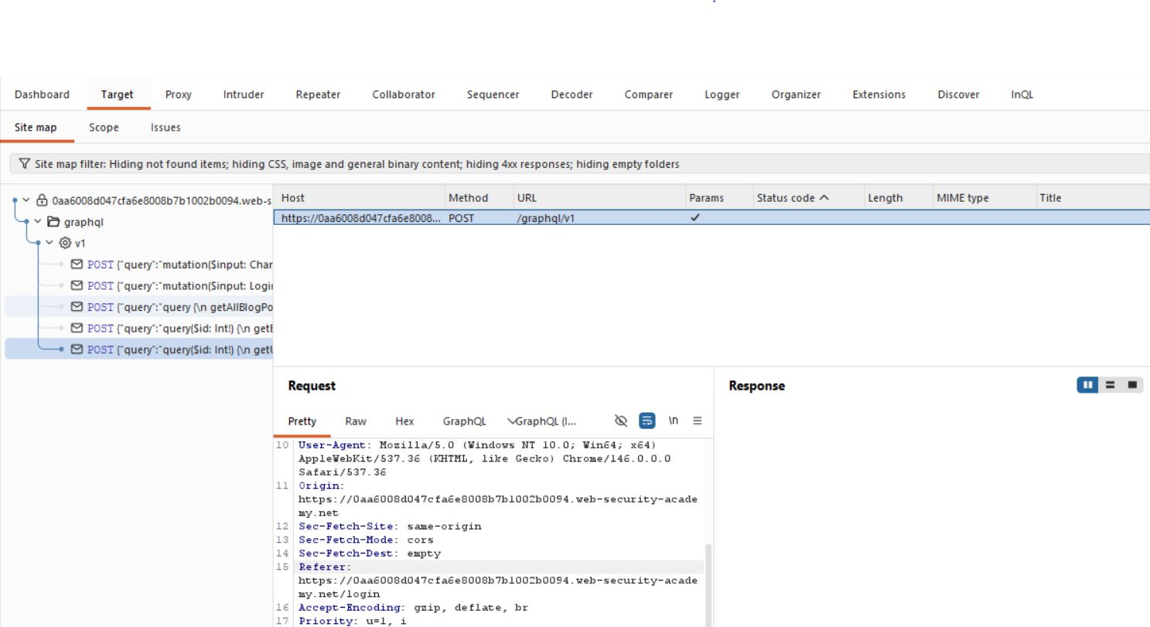
Figure 5: 5 Find Th Erequest
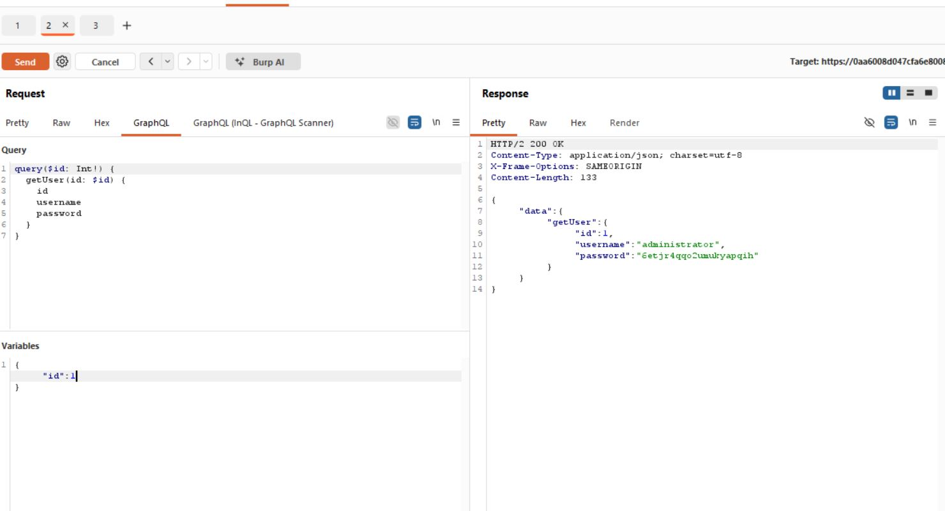
Figure 6: 6 Change The Id 0 1 Get Id Pass
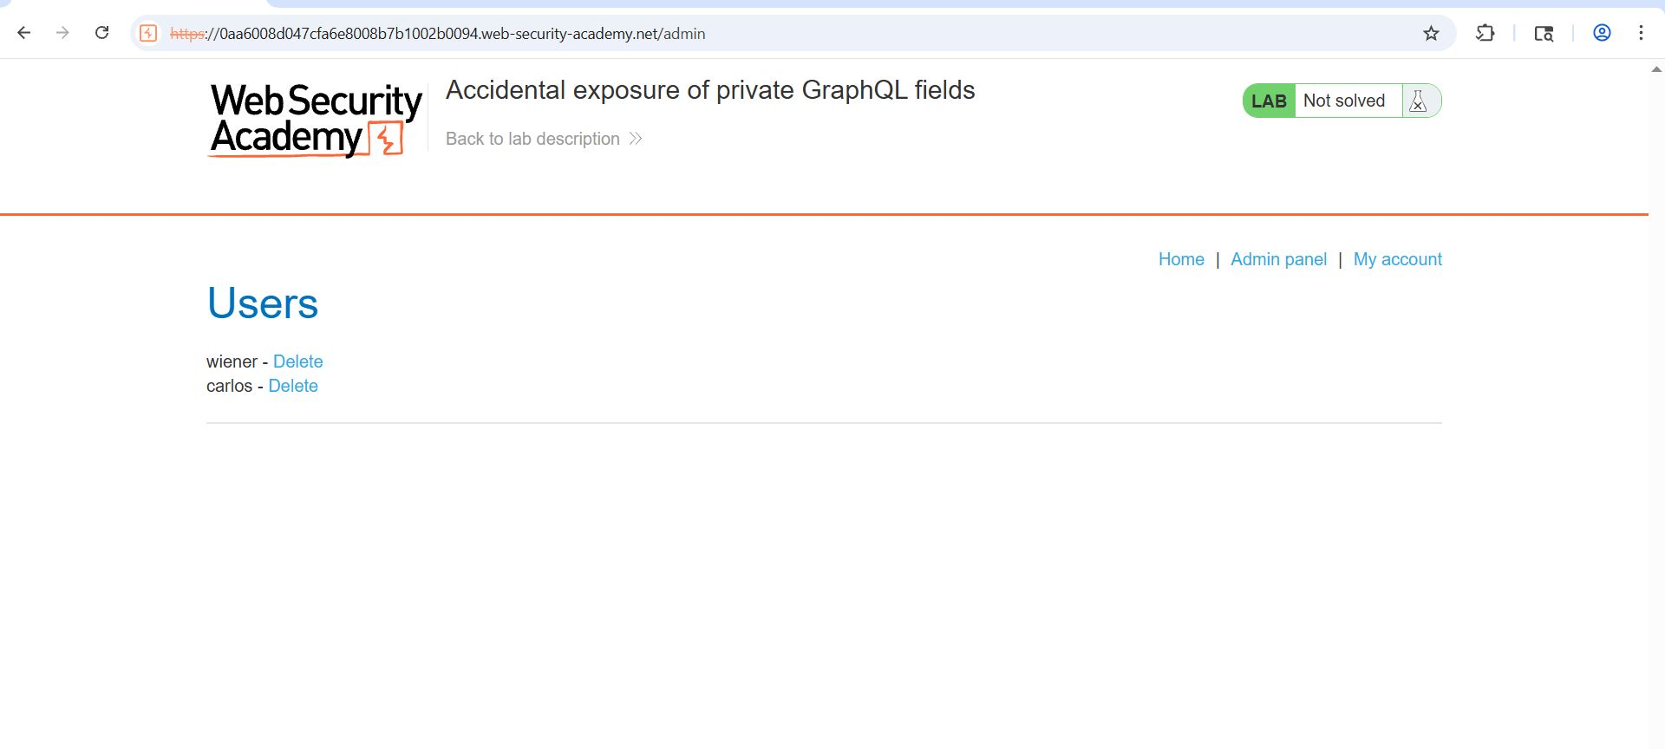
Figure 7: 7 Delete Acc
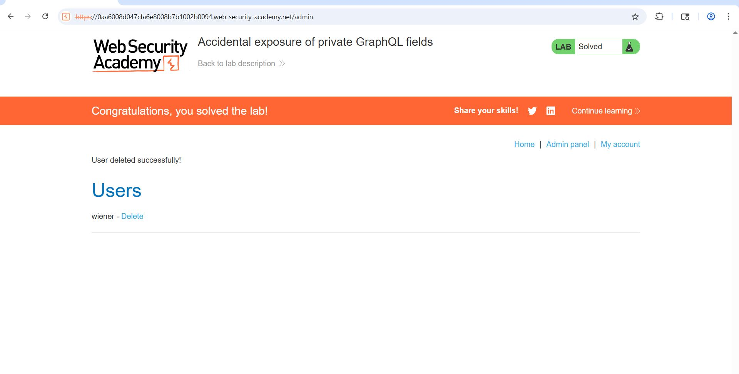
Figure 8: 8 Lab Splved

Lab Status: SOLVED

